Princess Sumaya University for Technology

King Abdullah II Faculty of Engineering

Electrical Engineering Department



**Embedded systems**

**FINAL PROJECT**

**Home security system**

|  |  |  |
| --- | --- | --- |
| *Authors:* |  | *Supervisor:* |
| Mohammad Abdalaziz  Omar Shunnar  Yazan Abugazah | 20200168 Computer engineering  20200291 Computer engineering  20200906 Nis engineering | Dr. Belal Sababha  Dr.Anastassia Gharib |
|  |  |  |

***Abstract***

This report presents the development of an intelligent home security system leveraging the capabilities of the PIC16F877A microcontroller. The system integrates LDR sensors and lasers for perimeter monitoring, a buzzer for audible alerts, and a door lock mechanism for physical security. Additionally, a microphone sensor is employed for sound detection, specifically recognizing clapping patterns. The system features a user-friendly keypad that not only unlocks the door but also activates the entire security system.

# TABLE OF CONTENTS

Contents

TABLE OF CONTENTS 1

1. INTRODUCTION 2

2. THEORY 2

2.1. Keypad Logic 2

2.2. LDRs and lasers 3

2.3. Microphone 4

2.4. Door lock- 3d printer 4

2.5. Dc motor (servo motor) 5

2.6. ADC 6

2.7. PWM 6

3. Diagrams 7

3.1 Circuit design 7

3.2 Software Design(Flow Chart) 8

4. conclusion 9

# INTRODUCTION

This report delves into an innovative smart home security system powered by the PIC16F877A microcontroller. Integrating LDR sensors, lasers, buzzer, door lock, microphone, keypad, and LCD display, the system offers a comprehensive solution for modern residential security. Emphasizing both effectiveness and user-friendliness, this introduction sets the stage for a closer examination of its key components and functionalities.

# THEORY

## Keypad Logic

The keypad in this project serves as a crucial input interface, facilitating user interaction and access control. Built on the principle of secure user authentication, it employs a combination of tactile buttons arranged in a grid formation. Each button corresponds to a unique alphanumeric character or symbol, contributing to the creation of a personalized access code.

The underlying theory involves the use of microcontroller logic, specifically programmed within the PIC16F877A, to interpret and validate user input from the keypad. Upon entering the correct access code, the microcontroller triggers a series of predefined actions, such as unlocking the door and activating the overall security system.

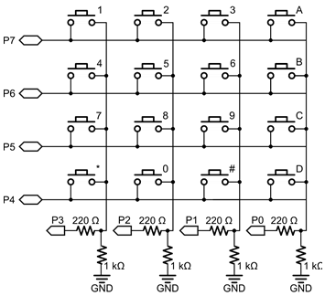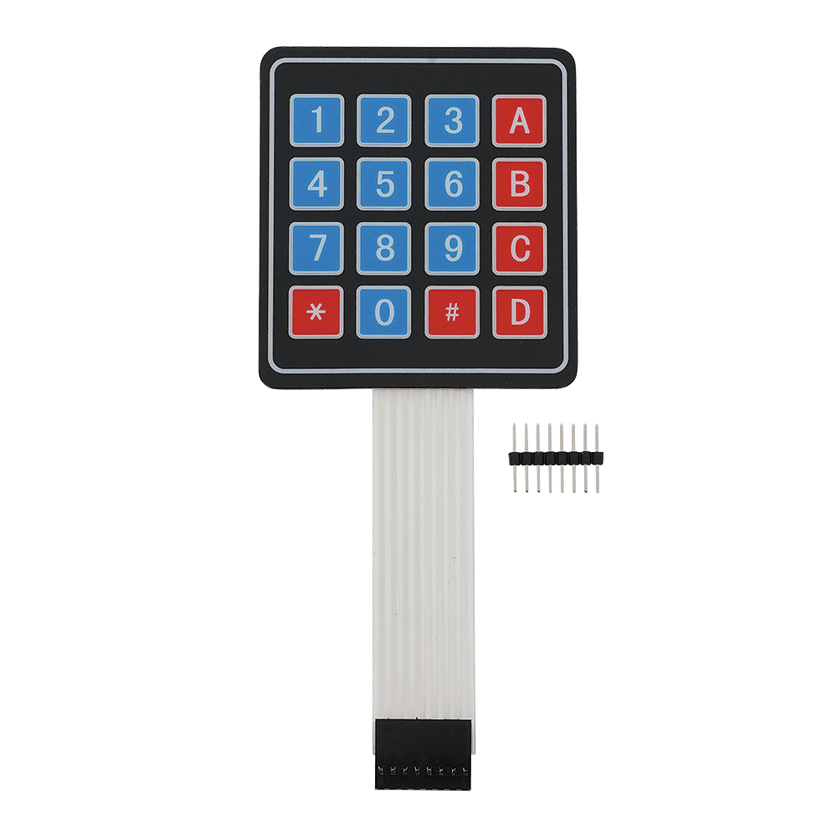

## **LDRs and lasers**

The Light Dependent Resistors (LDRs) combined with lasers in this project function as a perimeter detection mechanism, ensuring a proactive response to unauthorized intrusions. LDRs are passive optical sensors that exhibit a change in resistance based on the incident light intensity. When paired with lasers, this combination creates a reliable and efficient system for detecting disturbances in the defined perimeter.

The theory behind this component involves the emission of a continuous laser beam across the protected perimeter. The LDRs are strategically positioned to receive and monitor the laser light. In the absence of any obstructions, the LDRs register a consistent level of light, maintaining a stable resistance.

However, when an object or person disrupts the laser beam, the incident light on the corresponding LDR changes. This alteration in light intensity triggers a change in resistance, which is detected by the PIC16F877A microcontroller. The microcontroller interprets these resistance variations as potential intrusions and initiates the appropriate security responses, such as activating the buzzer.

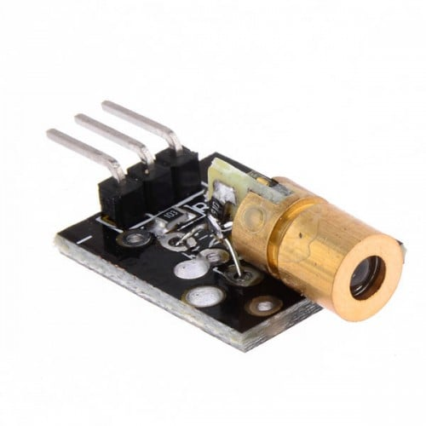The LDR-laser combination ensures a responsive and accurate detection system, capable of identifying perimeter breaches promptly. The theory emphasizes the reliability of light-based sensors and their integration into a comprehensive security framework, contributing to the overall effectiveness of the security system 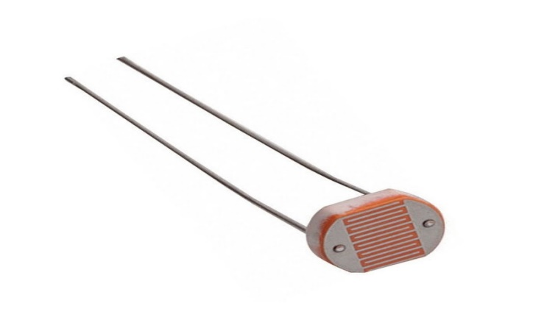

## **Microphone**

A microphone in this project is strategically placed to capture clapping sounds, utilizing the unique acoustic signature of clapping for user authentication. The electret condenser microphone, coupled with a PIC16F877A microcontroller, employs advanced algorithms and thresholding to distinguish genuine clapping from other noises. Adjustable sensitivity settings ensure reliable detection across different environments, and privacy considerations allow users to control when the microphone is active. This unconventional method enhances security by requiring knowledge of a specific action (clapping) alongside traditional authentication methods.

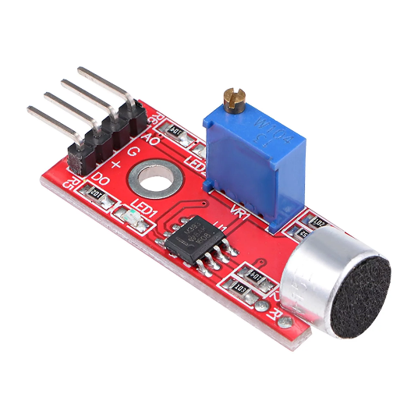

## **Door lock- 3d printer**

As for the door lock, we have made a lock that fit with the servo motor

To open and close door (shown in the fig down below), which makes the design more realistic.

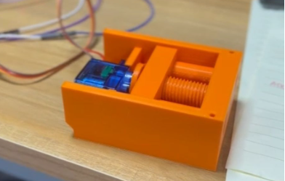 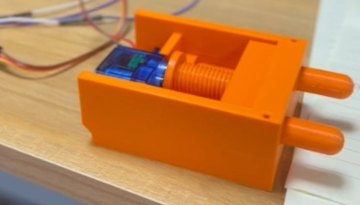

## **Dc motor (servo motor)**

The incorporation of a 360-degree servo motor into a door lock marks a significant advancement in smart home security. Unlike traditional servo motors, this innovative motor enables continuous rotation, allowing unrestricted movement for opening and closing doors. With precise control and versatile application, the 360-degree servo motor seamlessly integrates with smart home systems for remote access. The sleek design enhances aesthetics, while robust security features, emergency overrides, and regular maintenance ensure a reliable and secure door lock solution. This technology redefines door locking mechanisms, providing unprecedented flexibility and adaptability for modern smart homes.

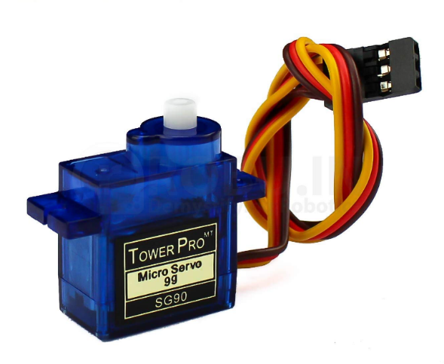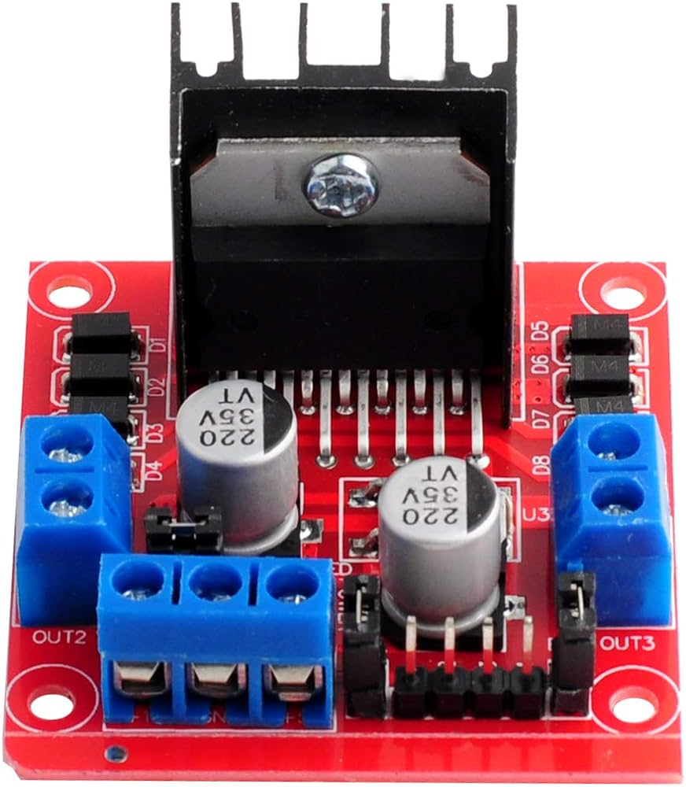

## **ADC**

We have added the ADC for LDR and Microphone sensors

1.ADC for LDR (Light Dependent Resistor) Sensor:

An ADC tailored for LDR sensors converts varying analog resistance from changes in ambient light into precise digital signals. This enables us to use it for accurate perimeter detection.

2.ADC for Microphone Sensor:

Designed for microphone sensors, this ADC converts analog sound waves into a digital format, capturing nuances in amplitude and frequency. Widely used in voice recognition, audio recording, and communication equipment, the ADC's precision ensures the ability to differentiate between the sounds and detect the sound of clapping specifically.

## **PWM**

PWM (Pulse Width Modulation) for Servo Motor Speed Control:

PWM is a crucial method employed in regulating the speed of servo motors with precision and efficiency. In this application, a microcontroller or PWM generator produces a series of pulses, and the width of these pulses determines the speed of the servo motor.

For speed control, the PWM signal is sent to the servo motor, and the duty cycle (percentage of time the signal is high) influences the motor's rotational speed. A higher duty cycle corresponds to a faster speed, while a lower duty cycle results in slower rotation.

This done with the use of the CCP capture functionality that is built in the pic, which in turns makes the duty cycle size calculations more accurate as it uses the hardware timers in the pic.

# Diagrams

## **3.1 Circuit design**

Circuit for our home security system that contains all sensors and actuators.

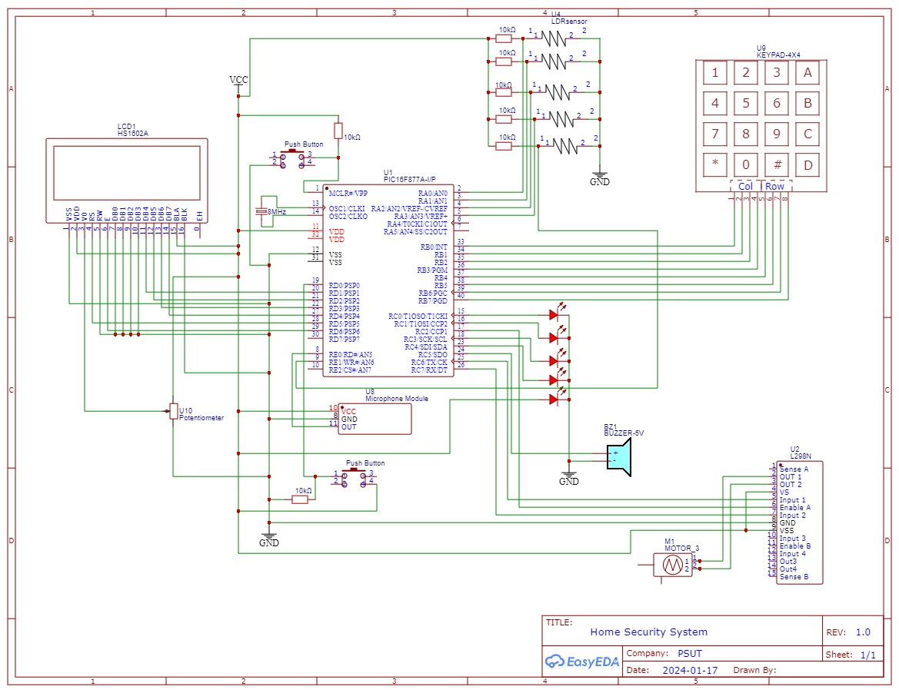

## **3.2 Software Design(Flow Chart)**

A full Software design that contain an easy and understandable design for our home security system

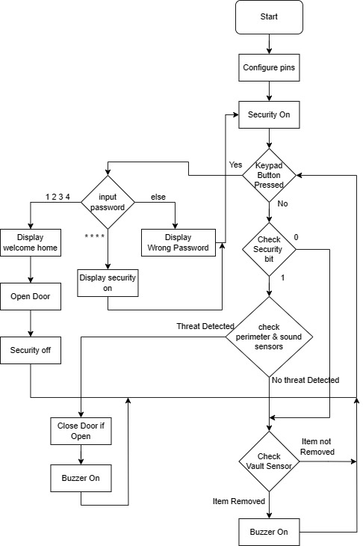

# 4. conclusion

In conclusion, our smart home security system combines cutting-edge technologies for a comprehensive defense. The strategic placement of microphones for threat detection, a user-friendly keypad for access control, and the use of Light Dependent Resistors (LDRs) and lasers for perimeter detection showcase our commitment to proactive security.

The integration of a servo motor with the door lock system allows for unrestricted movement, ensuring secure and convenient door access. This system not only prioritizes safety and responsiveness but also exemplifies a user-friendly approach to modern smart home security with the use of an interactive LCD.